Carbon Reduction Plan
Company name: Hillside Care Services

Company Registration Number: 06550222 Published date: September 2024

Commitment to achieving Net Zero
Hillside Care Services is committed to achieving Net Zero by 2045, we are aligning our target to aim to achieve a Net Zero value chain by 2045.

Baseline Emissions Footprint
Baseline emissions are a record of the greenhouse gases that have been produced in the past and were produced prior to the introduction of any strategies to reduce emissions. Baseline emissions are the reference point against which emissions reduction can be measured. We have chosen our baseline year to be April 2021 – March 2022.

Baseline Year: FYE 21/22
All Scope 1 & 2 Emissions have been measured, plus the following Scope 3 Emissions:
- Fuel & Energy Related Services
- Upstream Transportation & Distribution
- Business Travel
- Employee Commuting & Home Working
- Operational Waste & Water
EMISSIONS | TOTAL (tCO₂e)
Scope 1 | 0.000
Scope 2* | Market-based: 0.283 Location-based: 0.690
Scope 3 | 92.408
Total Emissions | Market-based: 92.691 Location-based: 93.098
*Purchased electricity can be measured in two ways. A location-based method reflects the average emissions intensity of grids on which energy consumption occurs (using mostly grid-average emission factor data). A market-based method reflects emissions from electricity that companies have purposefully chosen (or their lack of choice). A market-based method therefore takes into account the
purchase of electricity via a verified renewable energy tariff. We have chosen to base our Net Zero target on a market-based methodology.

Current Emissions Reporting

Reporting Year: FYE 22/23
All Scope 1 & 2 Emissions have been measured, plus the following Scope 3 Emissions:
- Fuel & Energy Related Services
- Upstream Transportation & Distribution
- Business Travel
- Employee Commuting & Home Working
- Operational Waste & Water
EMISSIONS | TOTAL (tCO₂e)
Scope 1 | 0.000
Scope 2 | Market-based: 1.394 Location-based: 1.859
Scope 3 | 97.580
Total Emissions | Market-based: 98.975 Location-based: 99.440
Our total emissions equate to a Carbon Intensity Metric of 0.442 tCO₂e per employee based on 224 employees during the measurement period (using market-based emissions).

Emissions Breakdown (FYE 22/23)
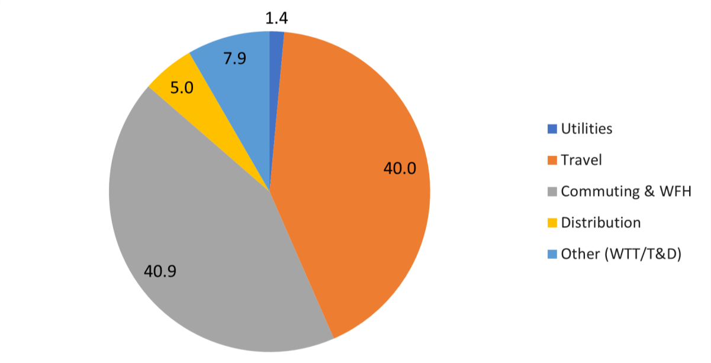

Emissions reduction targets
Hillside Care Services is committed to achieving Net Zero by 2045. To progress towards Net Zero and align with the NHS’s Net Zero supplier roadmap, this plan sets carbon reduction targets for currently measured emissions.

The below reduction targets address our measured emissions categories. We are aware that to achieve true Net Zero through absolute reduction in emissions, as defined by the Science Based Targets initiative (SBTi), we must achieve 90% reductions across our whole operational baseline once measured. In the future we may set employee intensity based reduction targets, however, we will await further guidance on this as SBTi is due to review target setting for SMEs in 2024.

To keep ourselves on track to achieve Net Zero we have set the following short and long-term targets for currently measured emissions:

Our near-term targets:
- Maintain Scope 1 emissions at 0 up to and beyond 2030.
- Procure 100% renewable electricity across all office spaces by 2030.
- Reduce measured scope 3 emissions by 4.39% a year, this will equate to a 30.73% reduction against our baseline year by 2030 and keeps us on track to achieve 90% reduction by 2045.

Our long-term targets:
- Reduce our total market-based emissions (scope 1, 2 and 3) by at least 90% by 2045.
- Neutralise any residual emissions using verified carbon offsets.

Our measured scope 3 emissions (yellow) and projections of reductions needed to achieve our 2030 reduction target (blue) can be seen in the graph below:
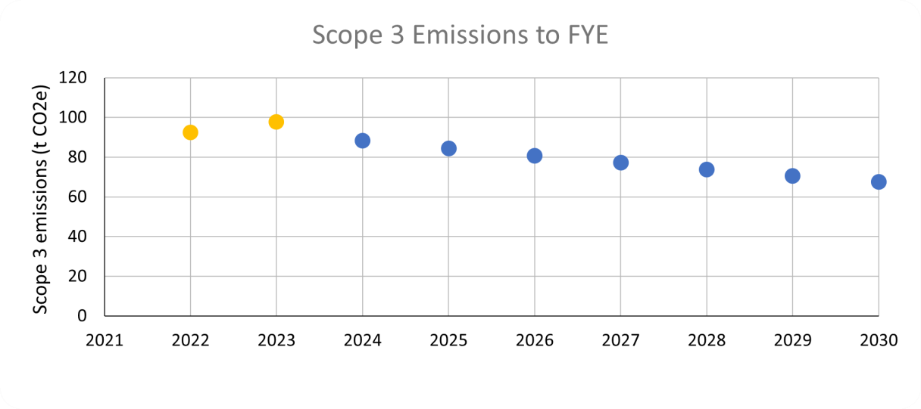

Carbon Reduction Projects

Completed Carbon Reduction Initiatives
The following environmental management measures and projects have been completed or implemented since the 2021-2022 baseline. There has been an increase in our absolute emissions since the baseline year, however, this was caused by increased travel and electricity demand post-covid. We will continue to monitor this in future years to assess whether our baseline measurement needs adjusting to reflect a normal operating year.

Activity | Completion Date | Scope
Commit to measuring carbon footprint of business activities year on year to gain an understanding of pinch points and regularly be making efficient and direct improvements to reduce these emissions. Appointed Positive Planet to support with calculating baseline carbon footprint and reduction recommendations. | 2022 | 1, 2, 3
Created a Green Team to lead initiatives. This team has been made up of members from different departments to support the roll out of initiatives and management of data, this includes sharing and collaborating throughout the organisation. | 2022 | 1, 2, 3
Took the decision to invoke the break clause on our London office and in addition, we significantly downsized our Leeds office to a space for only 24 desks and one meeting room which will helped reduce the number of colleagues working in an office environment. | 2022 | 2, 3
We are investing in the skills, capability and resources to carry out virtual and hybrid engagement, reducing the need for our team and the people we support to travel to meeting and events.  We have hybrid working and we consider hybrid or virtual meetings where possible balanced with the needs of our customers.  We have reviewed our processes and improved where possible for example, we have cut emissions for new/replacement laptops and these are issued straight from our supplier to the end user rather than to our office and then to the user. | Ongoing | 1, 2, 3

LED/PIR lighting controls implemented | 2022 | 2
Company EV scheme | 2022 | 3
Review and renew inefficient equipment (when at end of life), and actively consider the energy efficiency of equipment when new purchases are required (e.g. laptops, fridges, dishwashers). We have a renewal programme for older IT equipment for 23/24. We repurpose old equipment where possible. | Ongoing | Purchased  Electricity

Future Carbon Reduction Plans
In the future we will implement further measures, as detailed below:

REDUCTION PLANS – Scope 1 & Scope 2
Activity No. | Activity | Target Date | Category
1 | Ask the landlord to consider or report plans to implement options to improve the EPC rating of the building, such as improved glazing, insulation and/or adding heat & solar control reflective window sheets. Current rating B49  If in the future we need to procure more office space we will prioritise those with no gas heating to maintain 0 stationary combustion emissions. | 2026 | Stationary  Combustion,  Purchased  Electricity
2 | Encourage the landlord/management company at the office to procure a 100% renewable electricity tariff. This change will reduce market-based emissions (from chosen tariff) from the office (common areas) to 0 tCO2e. | 2030 | Purchased  Electricity
3 | Total location-based electricity emissions (National Grid energy mix) are still 1.859 tCO2e so there is an opportunity to reduce energy use.  The Green Team will encourage behaviour change initiatives within the workplace for reduction of emissions, including clear messaging for turning off lights, monitors, computers, and other electrical appliances where appropriate. | ongoing | Purchased  Electricity
4 | Ask the landlord to consider implementing energy efficiency measures to reduce the overall amount of electricity consumed by the building. They may consider optimising operational procedures and implementing energy management systems (such as ISO 14001).  Examples of reduction measures include upgrading lighting,  introducing more sensor lighting, installing timers on sockets/equipment. | 2030 | Purchased  Electricity

Based upon the above completed and planned initiatives, it is projected that combined Scope 1 & carbon emissions will decrease to 0 tCO₂e by 2030.

To reduce our Scope 3 emissions the below initiatives will be carried out. We will also continue to work towards expanding our measurement inventory to cover our entire up and downstream:

REDUCTION PLANS – Scope 3
Activity No. | Activity | Target Date | Category
1 | Consider training and engagement for the Green Team, leadership, and the wider employee base. Including and not limited to, creating spaces for environmental positive conversations (internal comms, newsletters, slack, Teams etc), certified Carbon Literacy Training for all applicable to roll out to further workforce and share with externals where appropriate. On average, certified learners reduce their carbon footprints by 5-15%, of which ~50% are work-related. | 2025 | Commuting  & Home  Working,  Business Travel
2 | Consider including questions in future homeworking surveys around employees homeworking environment to assess whether:  - Employees have gas heating.  - Employees are on renewable energy tariffs at home.  To support engagement with the above part of the Green Team’s initiatives should be driving wider employee engagement with the company's sustainability journey. This could include communicating the benefits of switching to a renewable home energy supplier. | 2025 | Home  Working
3 | Review logistics partners/couriers and utilise the above Sustainable Procurement Policy. Work with providers to gather their emissions data, and/or switch to lower-carbon providers.  Prioritise purchasing from local suppliers to limit delivery mileage. | 2024 - 2030 | Upstream  Distribution
4 | Review our travel policy to encourage further sustainability and to support environmental impact of choices when travelling, staying in hotels and commuting. The priorities within this policy will support active travel and low emission travel options where appropriate.  The organisation’s policy encourages the use of train travel for longer journeys as our preferred method of travel for longer journeys. | 2025 | Business Travel,  Commuting
Monitor and consider alternatives to air-based travel and commit to offering support to workforce with options for active travel schemes; such as bike to work or car sharing opportunities.
Utilise the emissions travel hierarchy – Digital communication
Walking & wellbeing
Cycling
Public and shared transport
Public and shared EV’s and car sharing
ICE vehicles and car sharing
Air Travel
Consider creative ways to engage and support workforce to influence change.
Examples include setting an internal organisation carbon credit scheme (limit that to a number of tCO2e per year), extra holiday days for low emission travel choice, subsidised travel, equal mileage payments for diesel/petrol/EVs/cycling.
5 | Review and enhance/improve existing company EV leasing scheme for employees in line with a review of the employee benefits system. | April  2025 | Business Travel,  Commuting

Based upon the above completed and planned initiatives, it is projected that our Scope 3 emissions will decrease in future measurements. For future measurements we are actively considering the effect of Covid-19 on our baseline.

Declaration and Sign Off

This Carbon Reduction Plan has been completed in accordance with PPN 06/21 and associated guidance and reporting standard for Carbon Reduction Plans.

Emissions have been reported and recorded in accordance with the published reporting standard for Carbon Reduction Plans and the GHG Reporting Protocol corporate standard and uses the appropriate Government emission conversion factors for greenhouse gas company reporting.

Scope 1 and Scope 2 emissions have been reported in accordance with SECR requirements, and the required subset of Scope 3 emissions have been reported in accordance with the published reporting standard for Carbon Reduction Plans and the Corporate Value Chain (Scope 3) Standard³.

This Carbon Management Plan has been reviewed and approved by Hillside Care Services Executive Team.

Signed on behalf of Hillside Care Services CIC:



_____________________________________________
Name: Richard Mukasa

Position: Director

Date: 04/09/2024

https://ghgprotocol.org/corporate-standard
https://www.gov.uk/government/collections/government-conversion-factors-for-company-reporting 3 https://ghgprotocol.org/corporate-value-chain-scope-3-standard

